**HTML/CSS Exercise:**

**1.How are inline and block elements different from each other?**

A block-level element always starts on a new line and takes up the full width available (stretches out to the left and right as far as it can).

**Eg: BLOCK**

<!DOCTYPE html>

<html>

<body>

<div style="border: 1px solid black">Hello World</div>

<p>The DIV element is a block element, and will always start on a new line and take up the full width available (stretches out to the left and right as far as it can).</p>

</body>

</html>

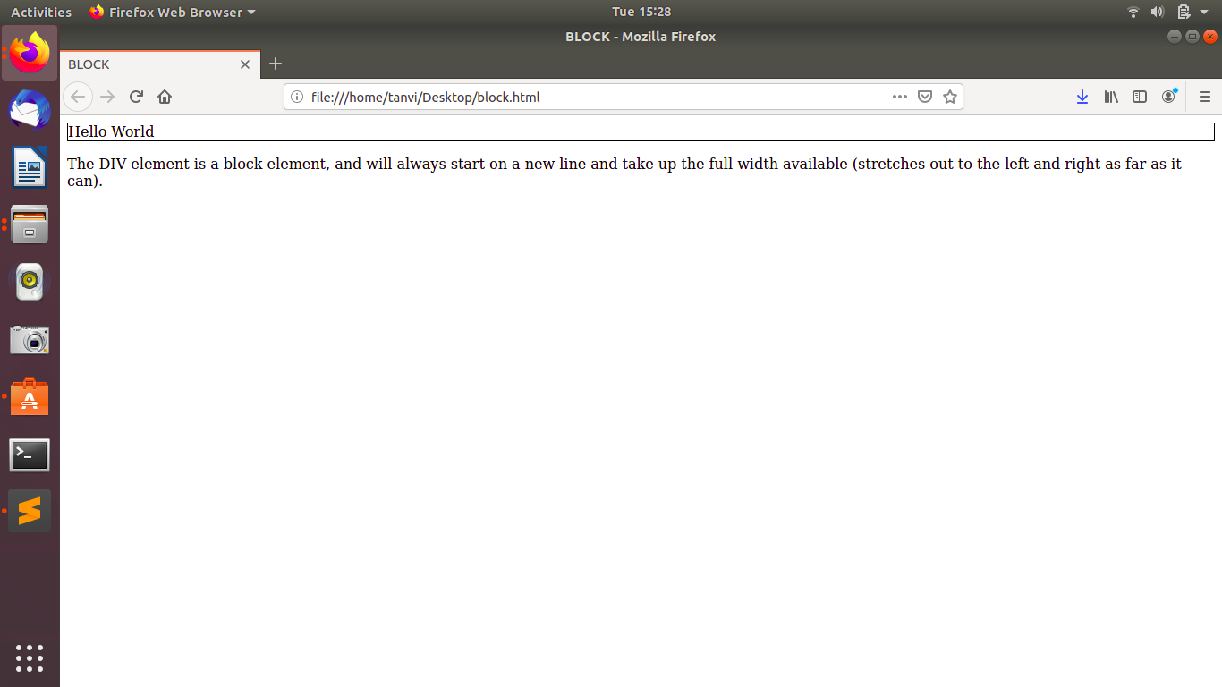

**Eg:INLINE**

<!DOCTYPE html>

<html>

<body>

<p>This is an inline span <span style="border: 1px solid black">Hello World</span> element inside a paragraph.</p>

<p>The SPAN element is an inline element, and will not start on a new line and only takes up as much width as necessary.</p>

</body>

</html>

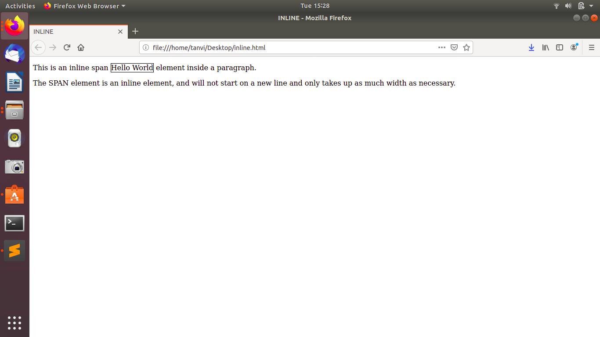

**2.Explain the difference between visibility:hidden and display:none**

The display: none property is used to hide elements without deleting them. It does not take up any space.

Eg:

<!DOCTYPE html>

<html>

<head>

<style>

h3 {

display: none;

}

</style>

</head>

<body>

<h2>This heading is visible</h2>

<h3>This is a hidden heading</h3>

<p>The hidden heading does not take up space even after hiding it since we have used display: none;.</p>

</body>

</html>

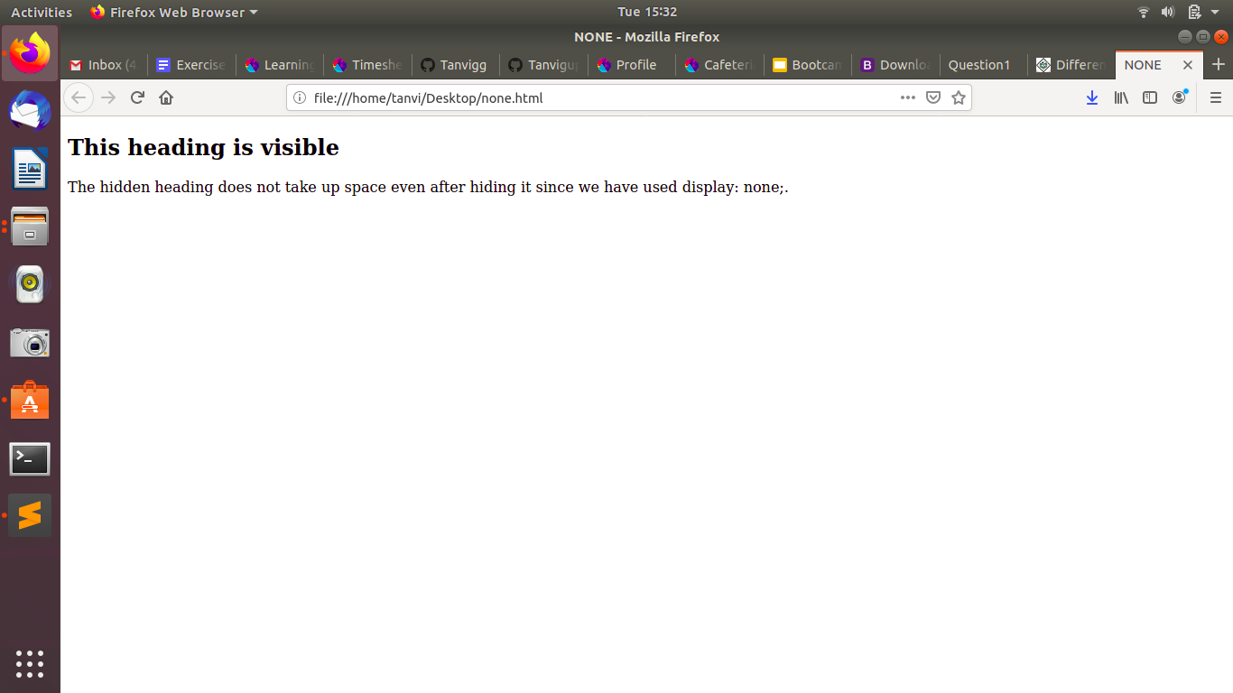

**The visibility: hidden property also hides an element, but affects the layout i.e. takes up space. Let us see an example:**

<!DOCTYPE html>

<html>

<head>

<style>

h3 {

visibility: hidden;

}

</style>

</head>

<body>

<h2>This heading is visible</h2>

<h3>This is a hidden heading</h3>

<p>The hidden heading takes up space even after hiding it.</p>

</body>

</html>

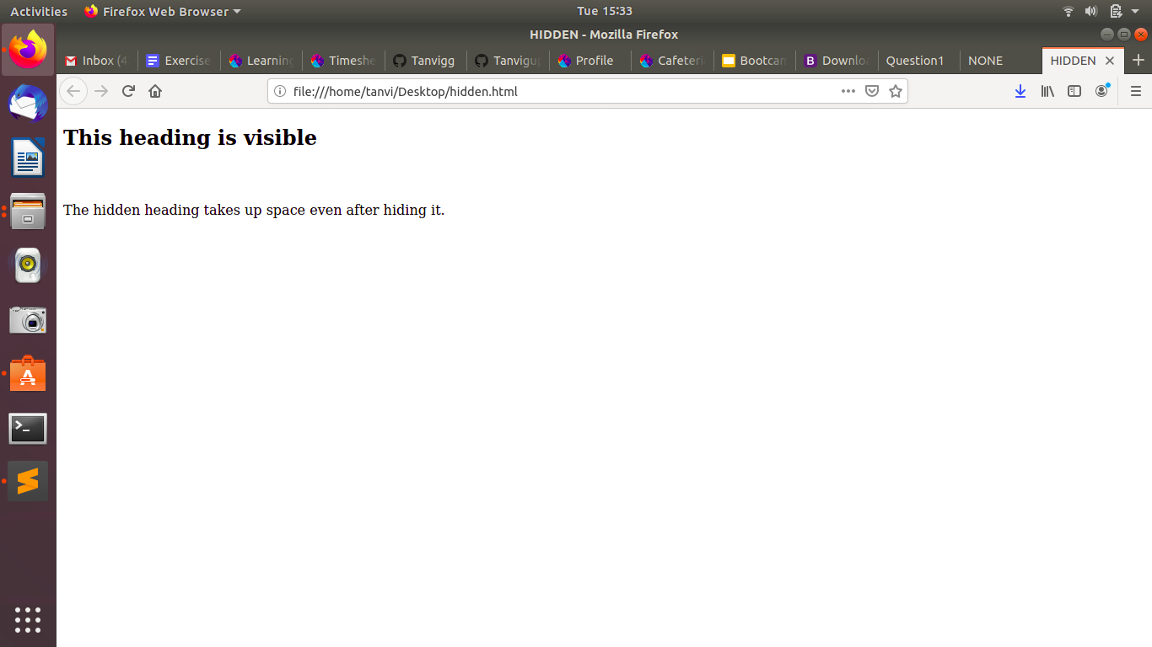

**3. Explain the clear and float properties.**

The **float** property is used for positioning and formatting content e.g. let an image float left to the text in a container.

The float property can have one of the following values:

* left - The element floats to the left of its container
* right - The element floats to the right of its container
* none - The element does not float (will be displayed just where it occurs in the text). This is default
* inherit - The element inherits the float value of its parent

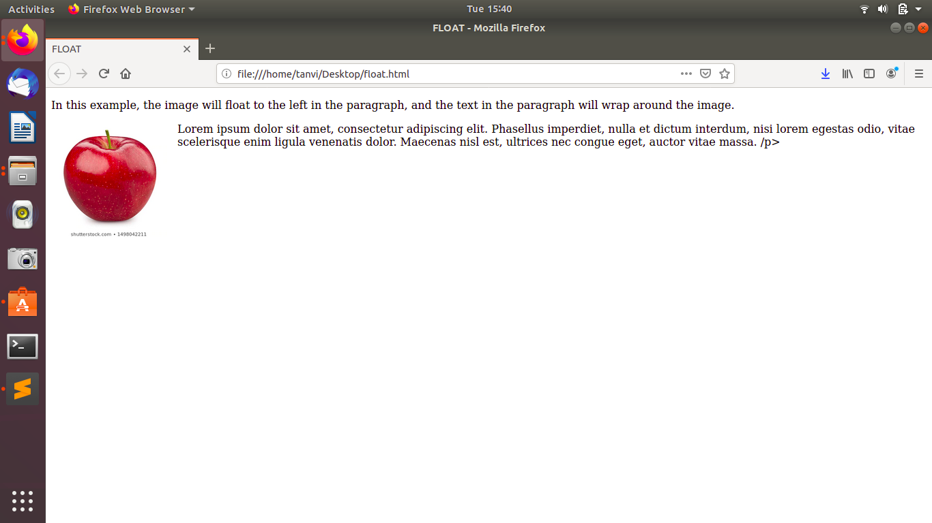

The **clear** property specifies what elements can float beside the cleared element and on which side.

The clear property can have one of the following values:

* none - Allows floating elements on both sides. This is default
* left - No floating elements allowed on the left side
* right- No floating elements allowed on the right side
* both - No floating elements allowed on either the left or the right side
* inherit - The element inherits the clear value of its parent

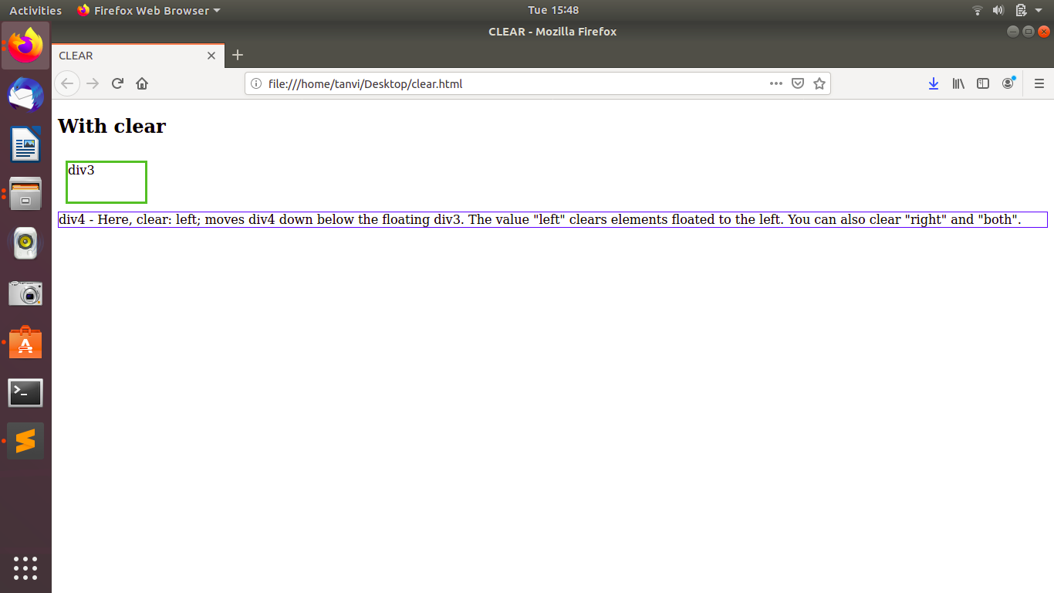

**4. explain difference between absolute, relative,fixed and static.**

**Relative:** Making an HTML element relative, gives you the privilege to move the element from its current position.

**Absolute:** Absolute positioning an HTML element positions the element to its nearest positioned parent.

**Fixed**: An HTML element positioned fixed is relative to the viewport and not to any other element.

**Static**: An element with position: static; is not positioned in a special away but it is positioned according to the flow of the page.They are not affected by properties like top, bottom, left, and right.HTML elements are positioned static by default.

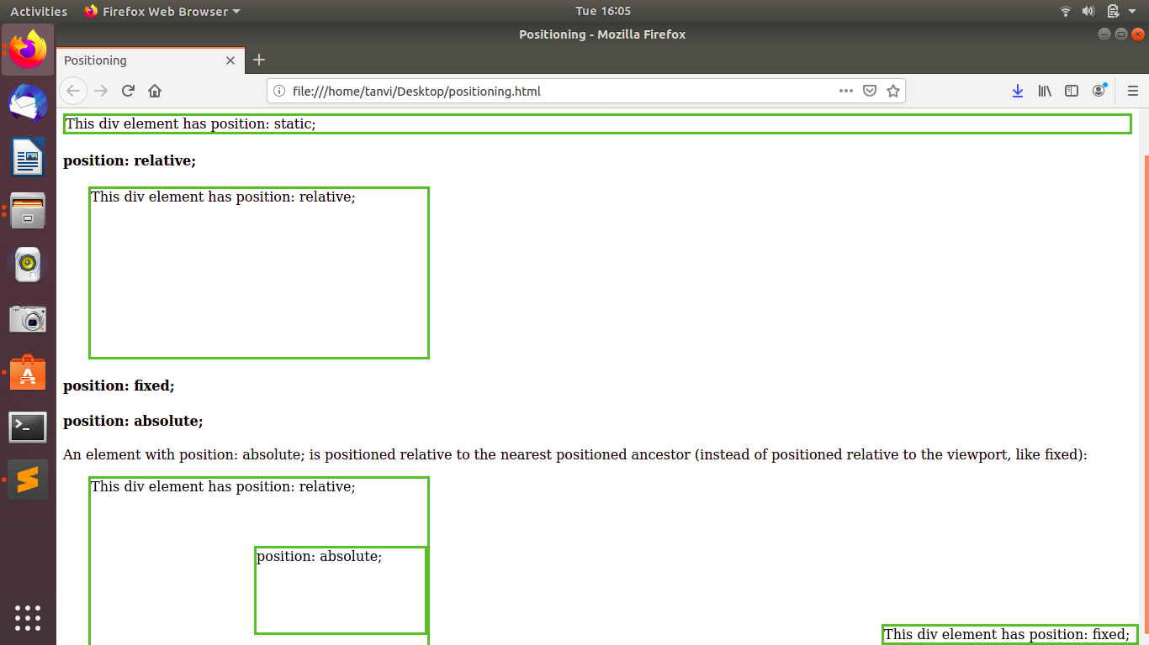

**5. Write the HTML code to create a table in which there are 4 columns( ID , Employee Name, Designation, Department) and at least 6 rows. Also do some styling to it..\**

Refer to: table.html

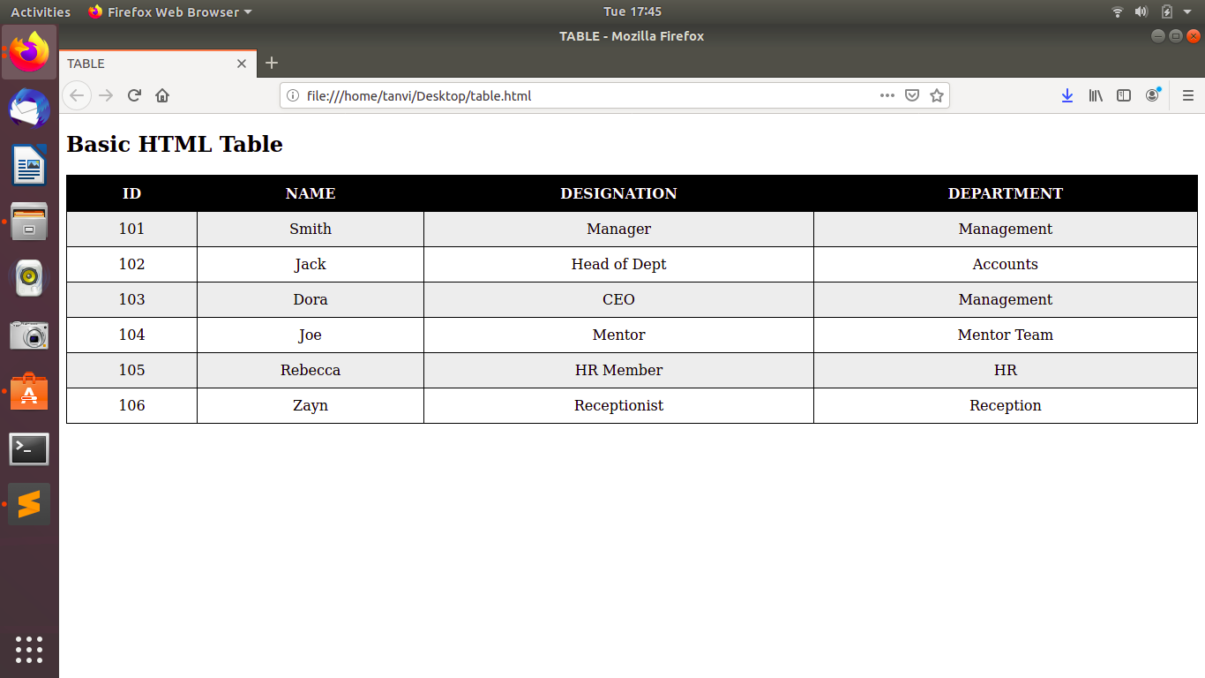

**6.Why do we use meta tags?**

The <meta> tag provides metadata about the HTML document. Metadata will not be displayed on the page, but will be machine parsable. Meta elements are typically used to specify page description, keywords, author of the document, last modified, and other metadata.

**eg:<meta name="viewport" content="width=device-width, initial-scale=1.0">**

**7.Explain box model.**

The box model allows us to add a border around elements, and to define space between elements.

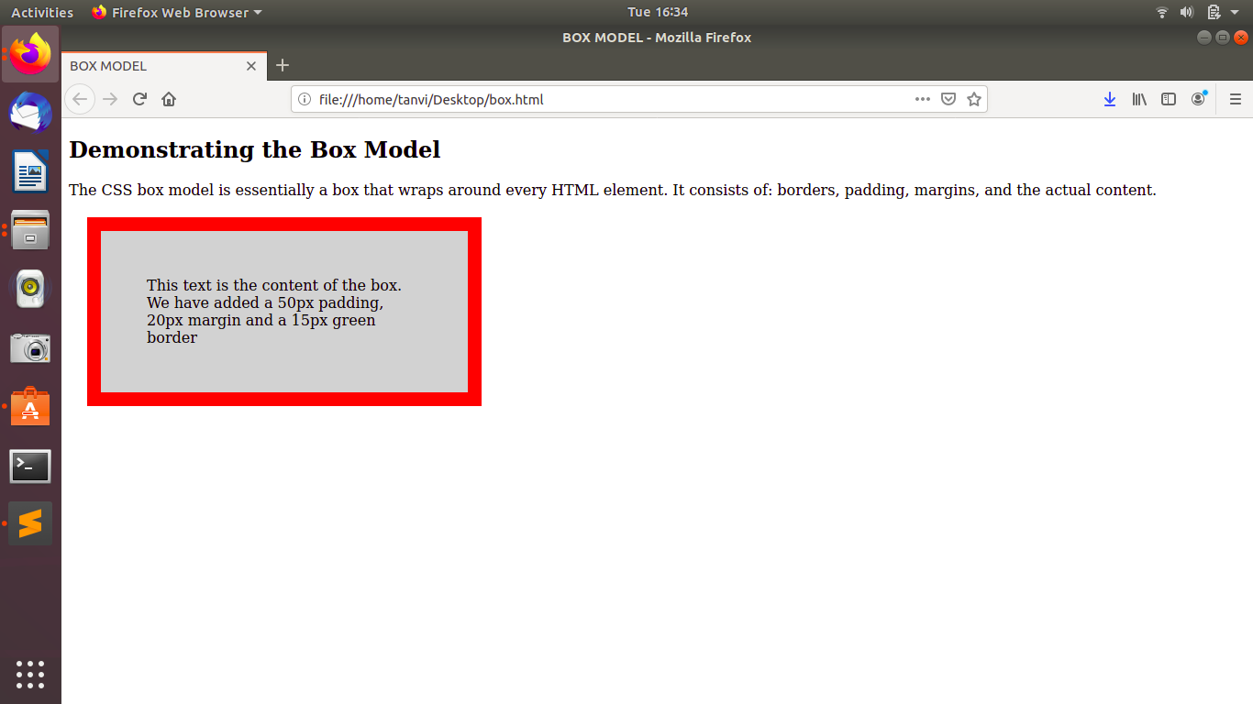

**8. What are the different types of CSS Selectors?**

The element selector selects HTML elements based on the element name.

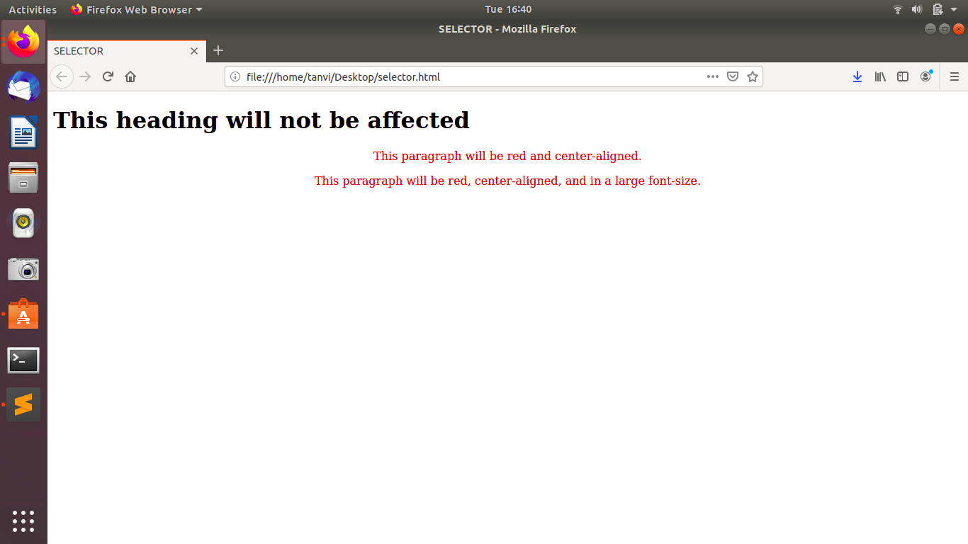

**9. Define Doctype.**

The <!DOCTYPE> declaration must be the very first thing in your HTML document, before the <html> tag.

The <!DOCTYPE> declaration is not an HTML tag; it is an instruction to the web browser about what version of HTML the page is written in.

**HTML 5:**

<!DOCTYPE html>

**10.Explain 5 HTML5 semantic tags.**

The <**section**> element defines a section in a document.

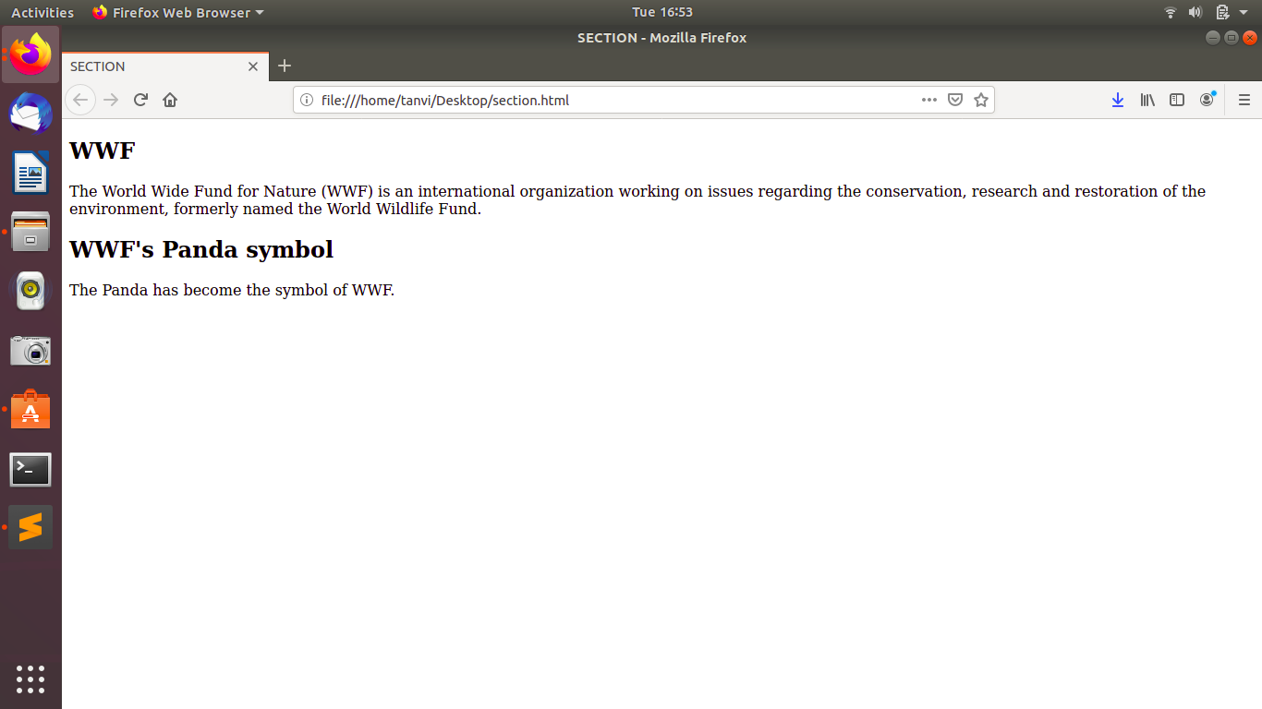

The <**header**> element specifies a header for a document or section.

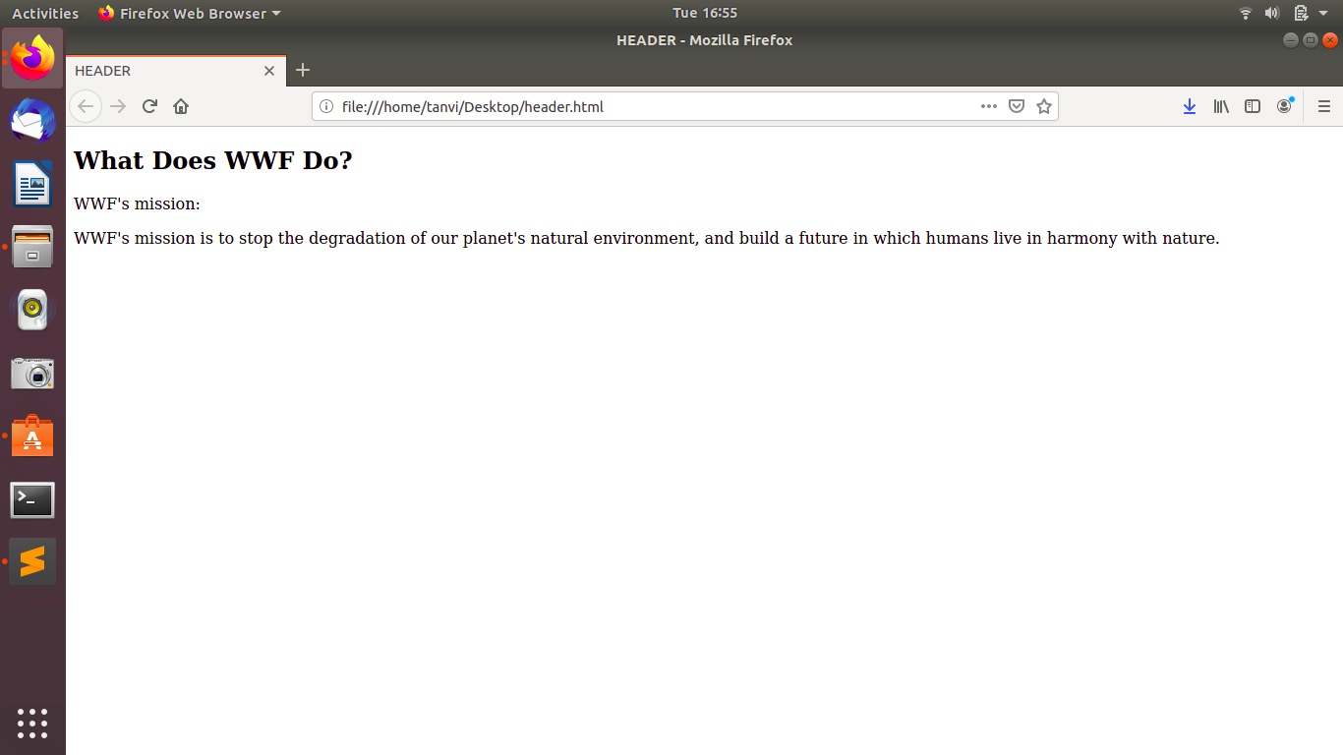

The <**footer**> element specifies a footer for a document or section.

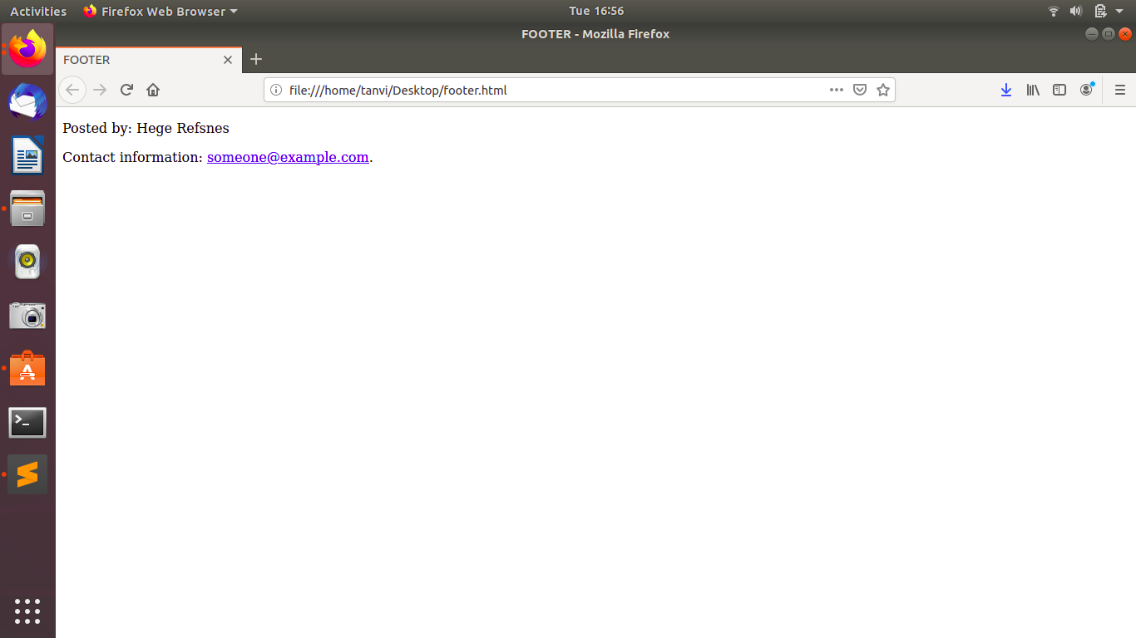

The <**nav**> element defines a set of navigation links.

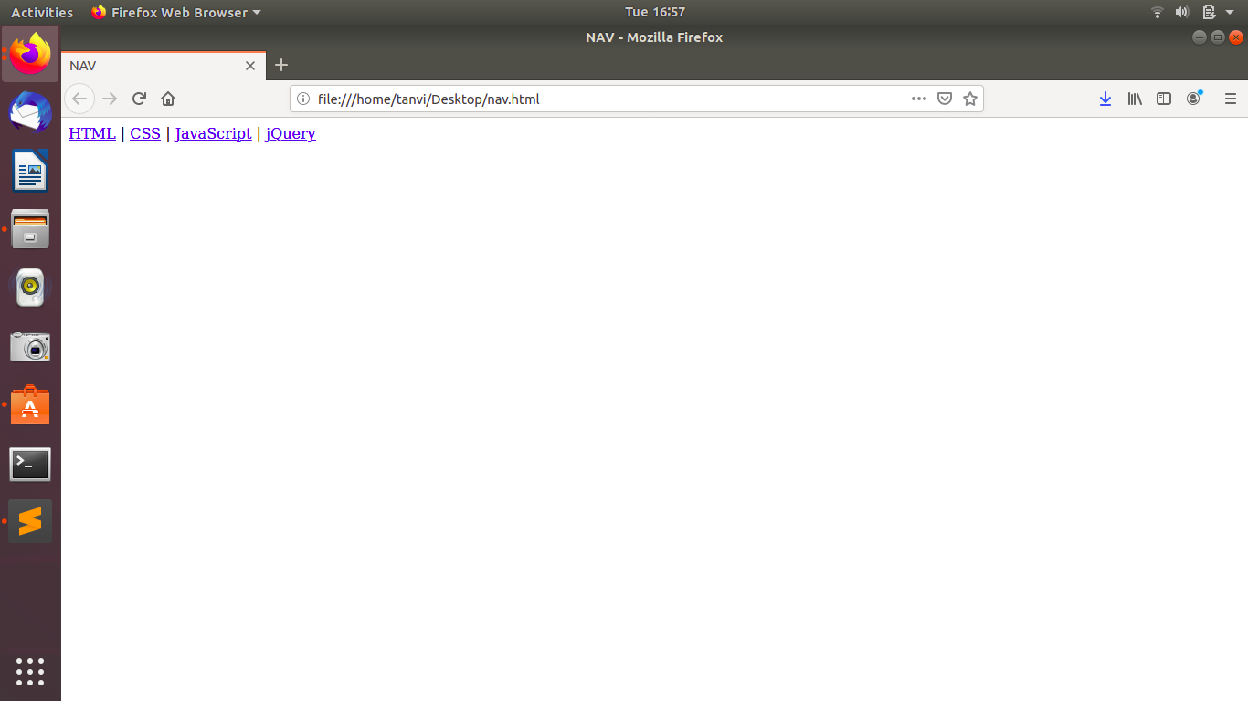

The <**aside**> element defines some content aside from the content it is placed in (like a sidebar).

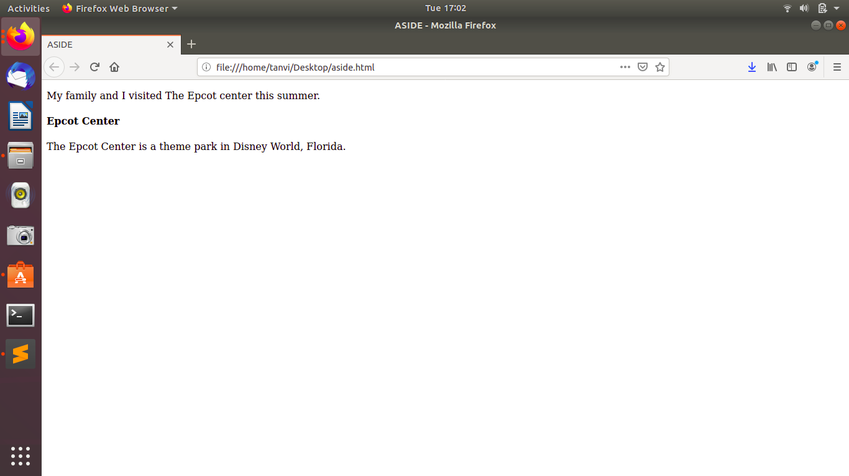

**11. Create HTML for web-page.jpg (check resources, highest weightage for answers).**

REFER FILE: Q1

**12. Create HTML for form.png (check resources, highest weightage for answers)**

REFER FILE: Q2